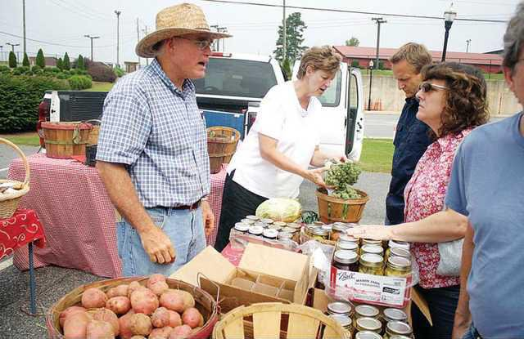

Insert Health Council logo or name

***“I’m really impressed with ____________. Now that is someone who is really making a difference right here in (county) and across the state.”***

The ________________ Health Council would like to see your name in this statement. That’s why we are inviting you to join us as an active member of the ______________ Health Council.

You’ll find a little background below. We’ll be a better health council if we can benefit from the views, input and ideas from all different groups of people in our community. Join us and make your Voice count in our work. Our members now also gain from extra training and support in capacities and skills useful not only in community work, but also in our own professional lives.

You probably have questions. I will make myself available to talk with you at a convenient time. We look forward to hearing from you soon.

Signature Position

**New Mexico health councils monitor community/tribal health status, equity, and root causes for poor health. They pinpoint key needs for change and prepare Community Health Plans. Councils work with others in the community to address needs, improve local health, and advise county, tribal and state leadership on policies that affect health.**

**Through *the 2019 NM County and Tribal Health Care Act (HB137)* and a unique initiative, our health councils are building greater capacity to engage more people in their community-based research, planning, community development, systems-change and policy efforts.**

***“The community-based focus that health councils have is significant because they are run by and for the communities that they serve*.” Members from every walk of life who care about their community well-being take part. We hope you will be one of those members to make the mission of this health council a reality.**